Settings for LAIPAC

By Andres Sosa

# Properties to be Set

## SETUP -> Network

* **APN**: M2M.T-MOBILE.com
* **APN Username**: [leave blank]
* **APN Password**: [leave blank]
* **GPRS Server IP**: 63.226.98.129:5036
* **GPRS Server Domain**: receiver.freedomsos.com

## SYSTEM -> Phone Book

* **Assistance Number**: 8883990381
* **Emergency Number 1**: 7273866959
* **Emergency Number 2**: 8883990381
* **Emergency Number 3**: 8883990381
* **SMS Base Station Number**: 7273866959

# Factory Properties

## Setup

### Device Info

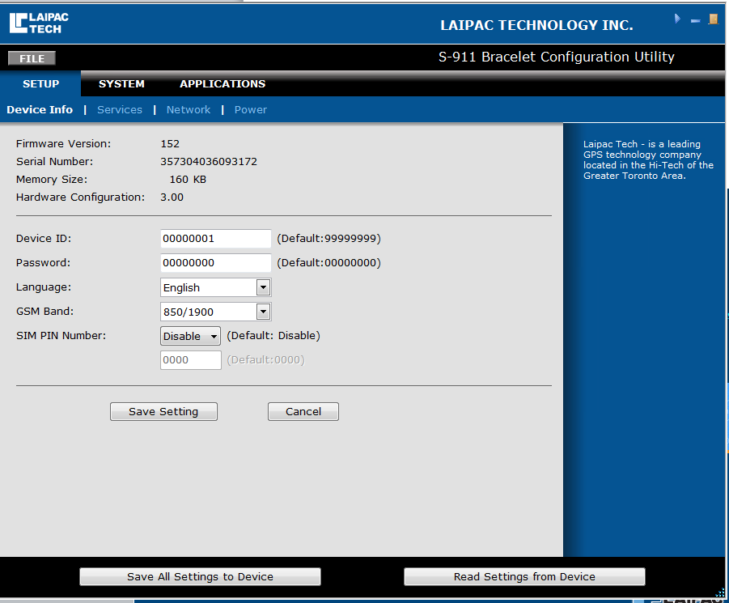

### Services

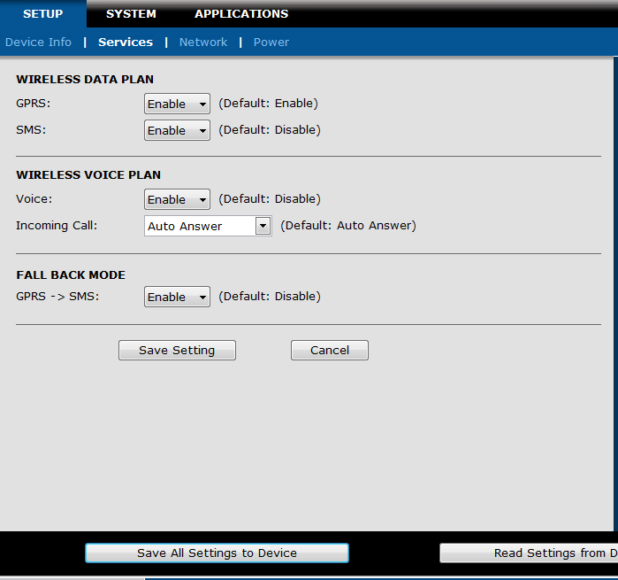

### Network

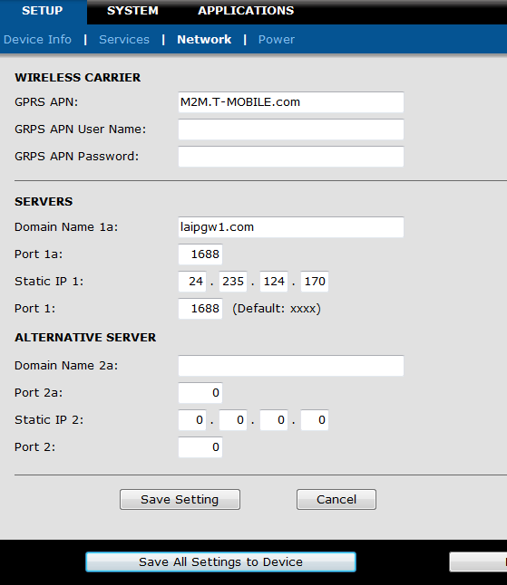

### Power

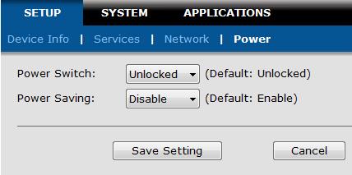

## System

### Report

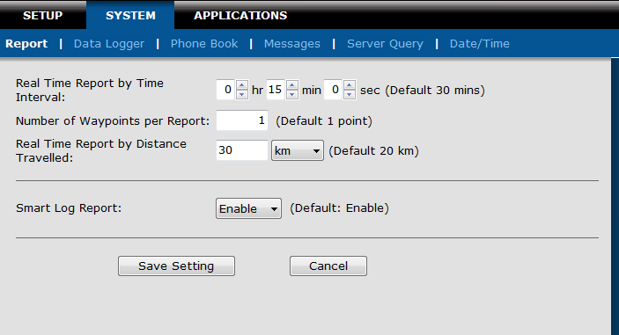

### Data Logger

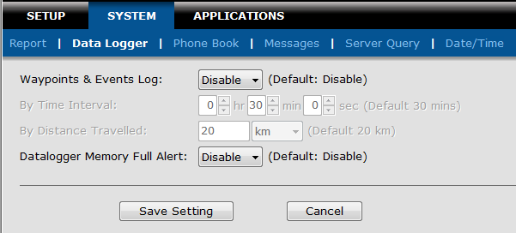

### Phone Book

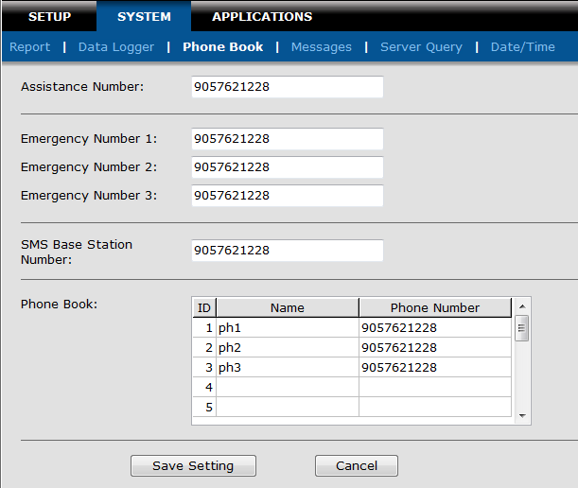

### Message

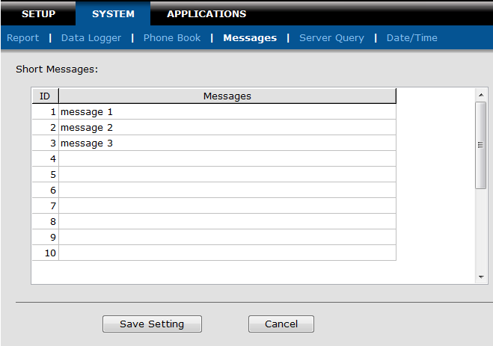

### Server Query

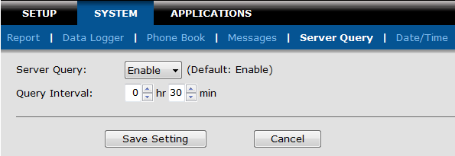

### Date/Time

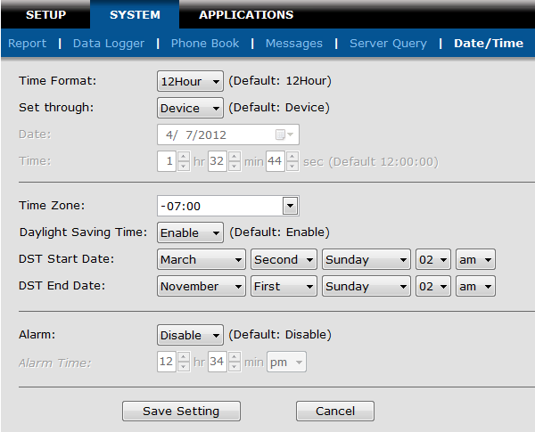

## Applications

### Speed & Mileage

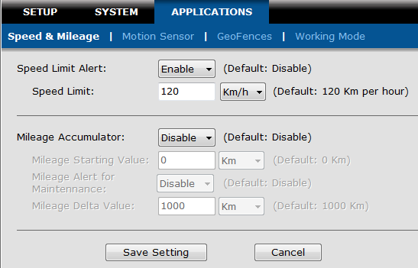

### Monitor Sensor

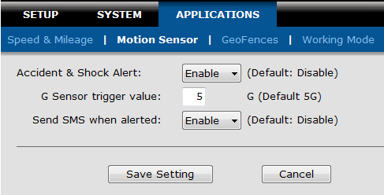

### GeoFences

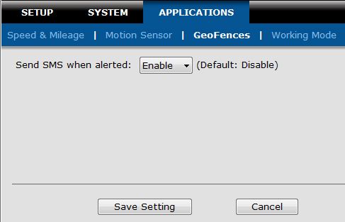

### Working Mode

